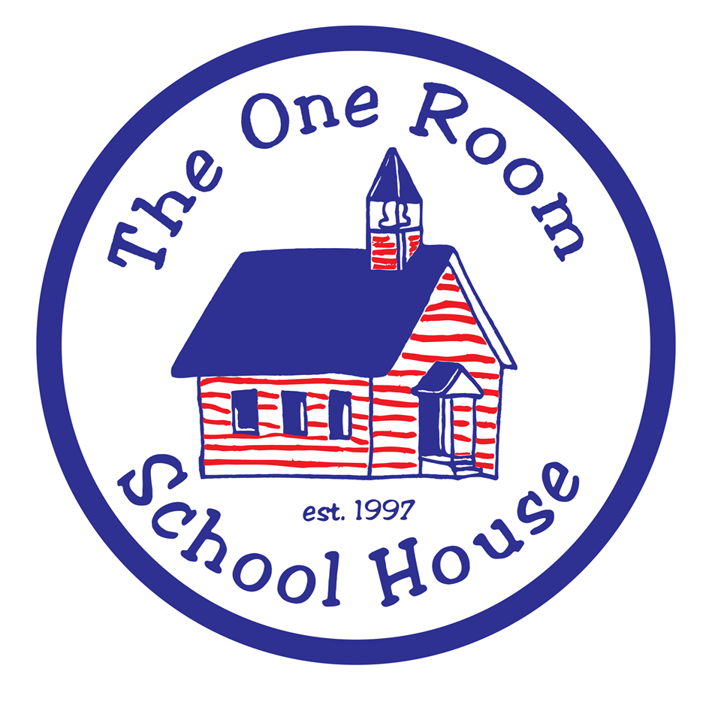

Gainesville’s first public charter school since 1997

An ‘A-rated’ District

BOARD MEMBERS
Michele Borst
Steven Borst
Arthur Newman
Michael Patrick
Sevan Terzian

BOARD REPRESENTATIVE
Neil Drake

3930 NE 15th St,
4180 NE 15th St.
Gainesville, FL
32609
.
www.orsh.net
(352) 376-4014

Recurring List 2023/24

NOTE: In order to reduce paper checks, auto payments may be made directly from the bank with prior approval from the Board Rep and confirmation signatures from Jeanne Minsavage.

- Postage
- Brannan
- Katell
- Unique Cleaning
- Staples
- Amazon
- ARIS/Amtrust//Wright Insurance
- Ricoh
- Xerox
- Sissines
- AT&T
- GRU
- Verizon
- Republic Waste Management
- SBAC
- Alachua County
- DOE
- Stacey Cricchio
- Fieldprint
- DCF
- Alachua Fire Exstinguisher
- Dart
- Aesthetic Print
- Florida Pest Control
- Charter Schools of Florida
- RE Schults
- Quickbooks/Intuit
- FL School Book Depository
- Craigslist
- CCB Credit Card
- Lowe’s
- CCB Mortgage
- AFLAC/Valic
- Alta Printing
- Educational Tours – DC Trip
- Funshine/Benchmark
- Gator CPR
- Indeed
- EFTPS
- Learning Without Tears
- Go Guardian
- Zoom
- Netflix
- Renaissance
- Santa Fe Storage
- Production Lab
- TpT

